Potential Opportunities, Barriers and Enablers to Use E-Learning within Libyan Medical Educational Institutions
Ajit Kumar, Mohamed A. Arteimi
Zawia Engineering College, 7th of April University, Zawia, Libya
ajitmaskara@yahoo.co.in
arteimi@yahoo.com

Abstract: An article published in The New York Times on March 20, 2009 gives a very clear message of Libyan citizens: “We don’t need money, we need roads, we need health care, education, and we need an economy”. There are only 13 doctors, 48 nurses, 34 hospital beds per 10,000 people in Libya. Similar to this, ample evidences are available to prove that Libya has a poor healthcare system. Citizens of Libya are partly dependent on neighbouring counties like Tunisia, Jordan, and Egypt etc. for their healthcare. One of the reasons for this quality of healthcare system is decline in the quality of working medical staff which is due to dearth of quality healthcare educational system of Libya. Recently the Libyan General Peoples Committee (GPC) has realized that Medical education is the cornerstone of building an effective healthcare system in any country and Libya is lagging behind in healthcare education. In fact, there is huge gap between healthcare education in Libya and other countries. To bridge this gap, Libya has started hiring medical teaching staff from different countries. At the same time, GPC strongly feels that traditional model of teaching (Instructor-centric) might take a long time to bridge this gap; therefore we should resort to new types of education to enable medical students to discover their abilities and possibly acquire knowledge through self-learning, that is, medical education should be Student-centric using E-Learning tools. Due to traditional teaching model constraints like lack of quality medical teachers, instruments for practical, contemporary infrastructure, the GPC highly recommended to adopt E-Learning model where it is possible to train a huge number of students without much difficulties. Government focused policy forced Libyan Medical Educational Institutions to go through a complete makeover and train 15,000 medical students immediately for a population of 6 million to improve overall healthcare of Libya. State-of-art E-learning infrastructures like WiMax, Mobile, landline are being developed rapidly. E-Learning system of education has definitely some potential opportunities and sounds very promising to improve Libyan Medical educational system, but unlike other countries, Libyan medical students, teachers, medical professionals have very different culture, attitudes, habits which might come as barriers as well as enablers for E-learning system. Obviously it is right time we identified potential opportunities, barriers and enablers for E-Learning within Libyan Healthcare Educational Institutions. Based on our analytical study, this paper identifies the potential opportunities for E-Learning system deployment in Libyan Medical Institutions, Barriers and Enablers to use E-Learning within Libyan Medical Educational Institutions and recommends a suitable model of E-Learning for Libyan Medical Educational Institutions.
Keywords: Libyan Healthcare, E-Learning, Medical Education in Libya.

- Introduction

The National Health Policy (NHP) declared by the General People's Committee (GPC) for Health and Social Security provides a framework for the National Health Strategy in accordance with which the health programmes are designed and implemented to deliver MEDICAL CARE TO ALL the citizens. This responsibility is contained in Public Health Law No. 106 of 1973, which states that health is a lawful right of all people and is to be guaranteed to them by the state. There is no doubt that Jamahiriya has been reasonably successful in raising the basic health of its citizens since 1973. For example, The Libyan individual’s average life span was only 46 years during the sixties. Now the average age is 70. The mortality rate for children aged under 5 years fell from 160 per 1000 live births in 1970 to 20 in 2000. In Egypt, the equivalent figure is 43 and in Tunisia, 28. Immunization records are also good. In 1999, 97% of one year-old children were vaccinated against tuberculosis and 92% against measles. However, despite all these improvements, the Libyan Arab Jamahiriya is still facing major healthcare problems, and the general population is discontent with the quality of healthcare services. They are dependent on neighbouring counties like Tunisia, Jordan, and Egypt etc. Some of the reasons identified behind this surprising fact are challenges like lack of Human Resource Planning, Production and Management, Absence of a National Health Information System, inadequate use of Information and Communication Technology for Healthcare, lack of Management and Accountability, Poor Coordination in National Institutions. Most of these healthcare related challenges can be addressed by addressing 20 % of the challenges (The Pareto Principle or 80/20 Rule) like:

- Human Resource Planning - There are no clear plans to match needs with number and categories of health personnel;

- Production of Quality Healthcare Professional - there is lack of need-based training; infrequent revision of curricula; lack of an accreditation system; weak intersectoral collaboration; lack of a link between continuous medical education (CME) programmes and career development; and inadequate training in management and;

- Management -There is an imbalance of available personnel, favouring urban areas and hospital practice and no systematic performance appraisal.

Again the highest ranking among the above three challenges goes to Production of Quality Healthcare Professional. There was a time when Libyan doctors were educated under high quality undergraduate educational system. Libyan government also funded Libyan doctors to pursue postgraduate specializations abroad. But later faced with low salaries and sanctions in Libya, those doctors opted to make their careers abroad obtaining good salary as well as high quality continuous education. It is estimated that there are about 800 Libyan doctors, who completed their undergraduate studies in Libya before moving to the UK to specialize, working in the NHS in the UK alone. Libya could not derive anything from the funds spent on scholarships for doctors to specialize abroad and now has been forced to import expensive foreigners to replace them. Libya still finds itself lacking in specialists in a number of key areas such as anaesthesia, cardiology and radiology etc. The standard of nursing care of Libya is also inadequate due to poor quality nursing education. Nursing practice is dependent on expatriate staffing. Most of the qualified nursing staff is not Libyan. Libya remains dependent on expensive foreign nurses for almost all quality and specialized nursing care, and for midwifery.

Experiencing bad experience in the past and considering the present poor medical workforce, the Libyan General Peoples Committee (GPC) decided to expand Medical education in Libya massively. Presently, Libya has over 15000 students in medical faculties, compared to just 9000 practicing doctors, and a total population of around 6 million. This move places enormous pressure on existing workforce of medical professional and obviously decline in quality of education. To handle this situation GPC is hiring medical teaching staff from different countries, developing state-of-art infrastructure etc. At the same time, government has realized that existing traditional model of teaching (Instructor-centric) might take a long time to train medical workforce due to constraints like quality medical teaching staff, instruments for practical and contemporary infrastructure. Therefore educational institution should resort to new types of education like distance learning, E-Learning so that the medical students can discover their abilities and possibly acquire knowledge through self-learning. GPC highly recommended adopting E-Learning model to all medical educational institutions where it is possible to train a large number of students without much difficulty.

Seeing the wonderful advantages and Government focused policy, many medical educational institutions in Libya are thinking to implement E-Learning model in near future and strong attempts are being made to identify and disseminate innovative E-Learning practices. E-Learning system of education has definitely some potential opportunities and sounds very promising to improve Libyan Medical educational system, but unlike other countries Libyan medical students, teachers, medical professionals have very different cultures, attitudes, habits which might come as barriers as well as enablers for E-learning system. Therefore in this paper we wish to identify factors such as potential opportunities, barriers and enablers for E-Learning within Libyan Healthcare Educational Institutions.

- E-Learning model in Libya - potential opportunities

2.1. Lack of medical professional

There are 13 physicians, 2.5 dentists, 2 pharmacists, 48 nurses per 10000 people. Comparing Libya with the neighbouring and the developed countries, there should be on average 19.8 physicians, 6.8 dentists, 4.4 pharmacists, and 66.6 nurses. Libya requires additional 4887 physicians, 3526 dentists, 1527 pharmacists and 13059 nurses as per the survey of 2004 (Please refer Table 1 & 2 for detailed explanation). It is evident that a good number of people need to be trained as soon as possible. At present Libya has 15000 students in medical faculties and traditional model may be time-consuming, expensive and very difficult to train these students when there are limited teaching staff and heavily lacking infrastructure. In such situations, E-Learning model can be very helpful. It is fast, inexpensive and does not require much infrastructure.

Table 1

Location | Physicians density  (per 10 000 population) | Year† | Dentistry personnel density (per 10 000 population) | Year† | Pharmaceutical personnel density  (per 10 000 population) | Year† | Nursing and midwifery personnel density  (per 10 000 population) | Year†
Libyan Arab Jamahiriya | 13 | 2004 | 2 | 2004 | 2 | 2004 | 48 | 2004
Tunisia | 13 | 2004 | 3 | 2005 | 3 | 2004 | 29 | 2004
Egypt | 24 | 2005 | 3 | 2004 | 13 | 2005 | 34 | 2005
United Kingdom | 23 | 1997 | 16 | 2000 | 5 | 1997 | 128 | 1997
United States of America | 26 | 2000 | 10 | 1997 | 9 | 2000 | 94 | 2000
Average | 19.8 |  | 6.8 |  | 4.4 |  | 66.6

Table 2

Location | Number of physicians | Year† | Number of dentistry personnel | Year† | Number of pharmaceutical personnel | Year† | Number of nursing and midwifery personnel | Year†
Actual Medical  Workforce | 7070 | 2004 | 850 | 2004 | 1130 | 2004 | 27160 | 2004
Desired Medical Workforce (Approximately) | 11957 | 2004 | 4106 | 2004 | 2657 | 2004 | 40219 | 2004
Resource Gap | 4887 |  | 3526 |  | 1527 |  | 13059

Source: © World Health Organization

Desired medical workforce approximately using formula [(average/10000) *Population of Libya (6,039,000)]

† Latest Data Available in WHO database

  - Unavailability of post graduate (Speciality and Super-speciality) medical courses

The first medical school was started in Benghazi in 1970 and the first graduate batch from this medical school came out in 1977 with less than 50 graduates. In 1973, the second medical school was opened in Tripoli (El-Fatah University, Faculty of Medicine). By 1978 about 500 students were enrolled in medical studies at schools in both Benghazi and Tripoli, and the dental school in Benghazi produced 23 graduates with first class degree. By Mid 1990, many other medical schools emerged and more than 10 medical schools were accepting students by 2003. The numbers of medical colleges are increasing year by year.

Table 3 and the corresponding chart (Figure 1) explain that only a few academic institutions offer post graduate studies in medical science. Compared with currently enrolled number of students in undergraduate medical courses, it seems that the country will be flooded with medical graduates very soon. To train these new graduates in short period, an effective and recognised postgraduate training is required. One way to train them is to send them abroad which might be expensive but again there are chances of brain drain. Something needs to be done to train graduates in Libya and retain them.

In most of the reputed world-wide institutions, the basic structures of post graduate studies are Continuing Medical Education (CME), Evidence Based Medicine (EBM), and Literature Based Medicine (LBM). Fortunately, E-Learning can support all these types of traditional learning in a very convenient and efficient way.
Table 3

University  Courses | Al-Arab Medical University, Faculty of Medicine, Benghazi | University of Al-Fateh for Medical Science, Faculty of Medicine, Tripoli | Tahaddi University, Faculty of Medicine, Surt | Sebha University, Faculty of Medicine, Sebha | 7th of April University, Faculty of Medicine, Zawia | Libyan International university for medical Sciences  (Private University) | Academy of Graduate studies | Medical Specialisations Assembly
Bachelor Courses (MBBS, BDS, B.Pharm.) | (MBBS, BDS, B.Pharm.) | (MBBS, BDS, B.Pharm.) | MBBS, BDS | MBBS,BDS | (MBBS, BDS, B.Pharm.) | MBBS,BDS, B.Pharm | - | -
Master Courses (MS, MD, MDS, M.Pharm.) | MS,MD,  M. Pharm | MS | - | - | - | - | - | -
PhD | PhD | - | - | - | - | - | - | -
Others (Diploma, Certificate Courses etc.) | - | - | - | - | - | - | Royal College exams membership  (MRCP &MRCS) | Libyan Board

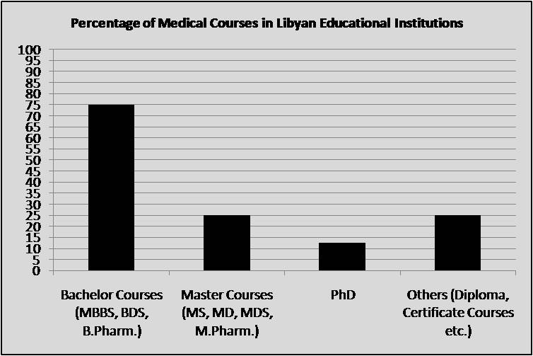

Figure 1
  - Social Culture demands for E-Learning

More than 80 % students in Faculty of Medicine are female and this figure exceeds all reported percentage of females in USA and European faculties of medicine. It has been observed that those females students, if get engaged or married, leave the faculty of medicine and if they are successful in the final year are not able to practice medicine which is a waste of time and money. Moreover some bright female students, who really wish to make career in medicine, find it difficult to keep their knowledge updated for longer time period through traditional mode of learning due to social culture of Libya. For example, women do not feel comfortable to go out of the house independently. Moreover they are socially scared of travelling long distance or abroad. Due to this, the degree of women’s participation and contribution in healthcare goes down due to lack of updated knowledge. E-Learning can be an ideal solution for them to update and upgrade their knowledge time to time without hampering their own valuable culture. Besides updating knowledge, they can upgrade their skills by perusing courses, which are rarely or not at all available in Libya, in their homely environment itself.

- E-Learning model in Libya – enablers

  - Students culture

Learning style varies from student to student. Some people, for example, find it easier to understand a concept by reading a textbook, while others prefer a verbal explanation. Likewise, people may vary in how they most effectively demonstrate their understanding - graphically, verbally, or in writing. E-Learning learners should possess the characteristics of having good computer and Internet skills, prefer listening and reading, being able to learn independently and view learning positively, being able to make the best use of their time, have self-disciplined, and enjoying working alone most of the time, being able to clearly express them in writing. As far as students of Libya are concerned, they prefer listening and reading to writing. It has been found that most of the time they do not use writing materials during lecture hours, but are pretty good listeners which is very much desirable in case of E-Learning mode of education. They are electronic gadgets (e-dictionary, calculators, PDA, mobile, digital diary) savvy; possess basic computer and internet skills.

  - Government focused policy

The government has taken strategic initiative to improve overall Libyan E-Learning infrastructure. For example, the Office of Teaching Media and Equipment provides computers, all the audio and visual teaching media, and the equipment, instruments and tools for training workshops and school laboratories; the initiation of an 18 month plan to provide one million computers to one million Libyan children; the initiation of a program to connect Libya to global educational community through broadband internet, WiMax, Mobile etc.

  - Upcoming state-of-art ICT infrastructures

Libya has moved from having virtually no lines after its revolution in the early 1969s, to having one in every 6 of its six million inhabitants now having telephone access. Considering small population, Libya has a substantial telecommunication infrastructure. There are 180 telephone exchanges, 13 earth stations, providing connections to the Arabsat satellite, and 10000 km of radio relay system, connecting the Mediterranean coast from Egypt to the Tunisian border as well as north to south within the country. In addition to Arabsat, Libya is connected to Nile sat, Intelsat and Util sat. National links are completely digitized. Libya is one of the internet service providers that has launched wireless network (WiMax) which is one of the most advanced in the world. E-Learning courses especially medical courses require good bandwidth due to lots of images in medical courses and the same can be made available through WiMax.
- E-Learning model in Libya - barriers

  - Culture of students and teaching staff

    - Fear of change to teaching staff and students- Changes are not simple logical processes and their way is not always smooth or linear. People view changes negatively as additional work for no additional benefit. Staff members in traditional teaching get used to relaxed atmosphere and adopted to the existing environment will resist any change, not only in the curriculum but also the module of learning. Moreover Changes are not only difficult for faculty members but also it will be a big change for students who are used to traditional teaching.

    - Instructor-centric students - Libyan students seek support from instructor all the time, i.e., they are highly instructor-centric, whereas E-Learning demands for student-centric learning style.

    - English language - Learning course designer develops modules keeping world-wide students in their mind as E-Learning model has great advantage of offering learning to students at anytime, anywhere. Obviously they will develop E-Learning courses in English language which is widely accepted language. Unfortunately, Libyan students do not have much knowledge of English which can be a stumbling block for them to take available online courses in English medium.

  - Copyright issue

Initial Investment (development cost, time, effort) is very high for development of courses. Any content that’s put online can be easily copied and reused, greatly depreciating the value of all work that has been invested in the first place.

  - ICT infrastructure accessibility, maintenance and awareness

Libya still lags behind in terms of usage of ICT infrastructure and its maintenance. The process of implementing the national ICT policy in particular and development projects in different domains in general, are still at an early stage.

- Accessibility - Internet facility is not available at all places in Libya especially interior places. E-Leaning is a preferred medium for people in the interior area due to unavailability of traditional teaching. Moreover internet and mobile communications is very expensive making people indirectly inaccessible to Internet.

- Maintenance - Local networks maintenance is in poor condition. In total there are 1.1m fixed lines and they suffer inadequate maintenance.

- Awareness - E- learning as well as Learning Management System awareness is very less in Libya. According to Sami H Alamari, commercial manger of LTT (Libya Telecom and Technology), while the internet is rising in popularity, the market is not sophisticated in its knowledge of the net and its uses. MSN instant messenger and chat rooms are popular with young Libyans, but there is little awareness of the other uses of the net for educational and commercial purposes.

- E-Learning model in Libya – pros and cons

As discussed earlier, implementation of E-Learning model in Libya has many advantages over traditional model of learning. No doubt it removes some major constraints like time, place, and cost, but at the same time it brings many disadvantages. For example, E-Learning educational model do not provide much opportunity of writing and speaking to students thereby a chance to degrade the writing and face to face communication skills. There is also possibility of widening the relationship gap between teachers and students. So many other unseen negative consequences may arise in future. Therefore, a very special care should be taken before implementing E-Learning model. E-Learning should not be implemented because everyone else is implementing. In our earlier sections, we mainly discussed pre-implementation perspective of E-Learning model in terms of opportunities, enablers and barriers, but it will be a wise decision for medical educational institutions if they do some sort of analysis to find possible post-implementation outcomes. As per latest research, blended model (a right mix of traditional and E-Learning) is a good model in the beginning stage. Figure 2 shows E-Learning continuum. It is responsibility of decision maker to find where they are now in E-learning Continuum; and where they should try to reach in near future.

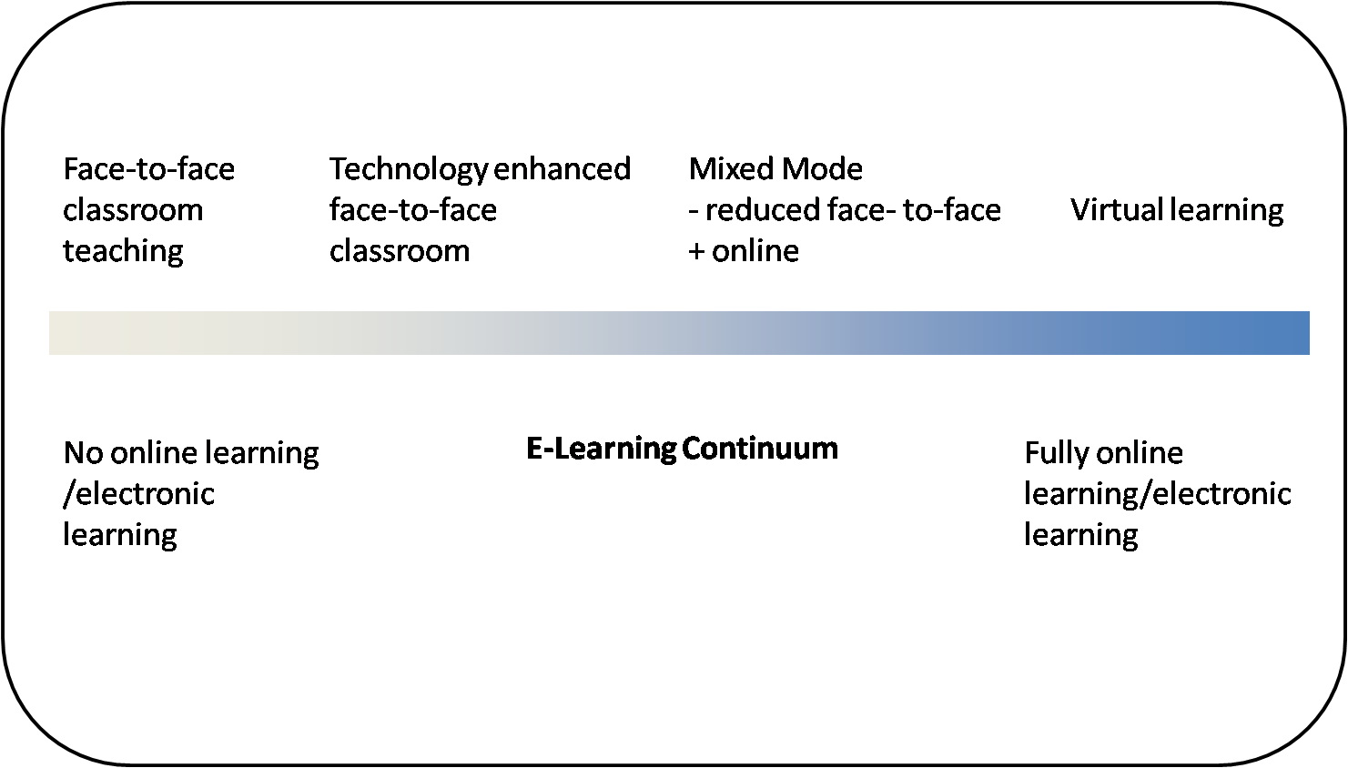

Figure 2 - E-Learning Continuum

- Summary

Table 4 gives summary of all the above sections.

Table 4

E-Learning Model in Libya
Potential Opportunities | Enabler | Barriers
- Lack of Medical Professional like physicians, dentists, pharmacists, nurses and paramedical staff | - Student Culture - Like watching and listening rather writing.  Electronics gadgets savvy – like e-dictionary, calculators, PDA, mobile. Moreover they possess IT Skills. | - Fear of change to teaching Staff and students.  - Self-study attitude is less, students are instructor-centric  - Poor English Language
- Unavailability of Post Graduate (Speciality and Super-speciality) Medical Courses | - Government focused policy | - Copyright Issue – No Intellectual Property act in place
- Social Culture demands for E-Learning | - Upcoming State of art infrastructure - Mobile, Internet - WiMax, Broadband | - Internet NOT available at all places in Libya and It is Expensive  - Poor maintenance of Infrastructure  - Inadequate Awareness of Learning Management System software

- Conclusion

E-Learning can prove fruitful in meeting the challenges of healthcare in Libya. But, a very special care should be taken to analyse opportunities, enablers and barriers of E-Learning before their implementation. Moreover all types of pros and cons should be taken into consideration in order to find out a suitable form of E-Learning model for Libya.

- References

Abdelraheem, A. Y., “The Implementation of E-Learning in the Arab Universities: Challenges and Opportunities” DLI 2006, Tokyo, Japan
Arteimi, M., Bouker, M., “Utilizing Learning Styles for Effective Web-based Learning”, International Conference on E-Learning, Cairo 2007
Borduas, F., Denis, D., Rouleau, M., LaBelle, D., Lamoureux, C., "Profile of E-Learners in Canada” Continuing Medical Education Center, Laval University, Quebec City, Canada, Medical Communication Department, Pfizer Canada, Kirkland, Quebec
Eastern Mediterranean Regional Health Systems Observatory, “Health Systems Profile- Libya 2007”, available at http://gis.emro.who.int/HealthSystemObservatory/PDF/Libya/Full%20Profile.pdf
Gary, D., Palmer, J., “Learning Styles and Web-Based Learning - The 4MAT Methodology”, WebNet Journal, 3/2, April-June (2001)
Hadeli, K.O., “Medical Education in Libya”, Jamahiriya Medical Journal Vol.7 No.1 (spring) 2007 available at www.jmj.org.ly
Hugenholtz, N. I. R., de Croon, E. M., Smits, P. B., van Dijk, F. J. H. and Nieuwenhuijsen, K., "Effectiveness of e-learning in continuing medical education for occupational physicians" available at http://occmed.oxfordjournals.org/cgi/content/full/kqn053
Hassanzadeh, P., "Comparison of e-learning and lecture-based approaches in medical education" Tehran, http://education.tums.ac.ir/UserFiles/File/Elearning%20Conf/8-dr%20hassanzadeh.pdf
Metz, H. C., Libya: A Country Study. Washington: GPO for the Library of Congress, 1987 available at http://countrystudies.us/libya
Oxford Business Group, “On the move – The sector is getting wired, going wireless and expanding its base: The Report Libya 2008” available at http://www.oxfordbusinessgroup.com/publication.asp?country=62
Public Health Law No. 106, Tripoli, Libyan Arab Jamahiriya, 1973
Sagher, F. A. “What’s wrong with medical education in Libya?” Jamahiriya Medical Journal, Libyan Board of Medical Specialties, Libya
World Health Organization, Regional Office for the Eastern Mediterranean Cairo, 2006 “Country Cooperation Strategy for WHO and the Libyan Arab Jamahiriya 2005–2009”, available at http://www.who.int/countryfocus/cooperation_strategy/ccs_lby_en.pdf

